Deployment of Swiggy Application using GitHub Actions

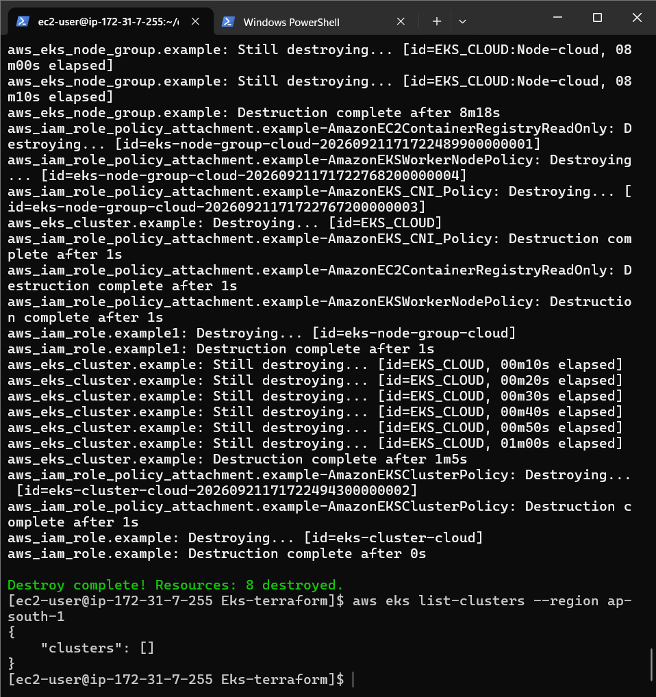

Eks destroyed

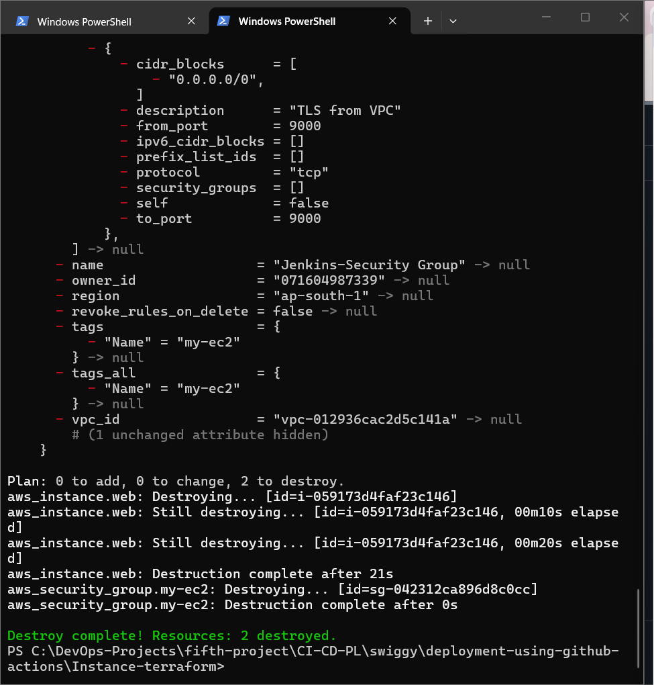

Ec2 destroyed

winget install HashiCorp.Terraform

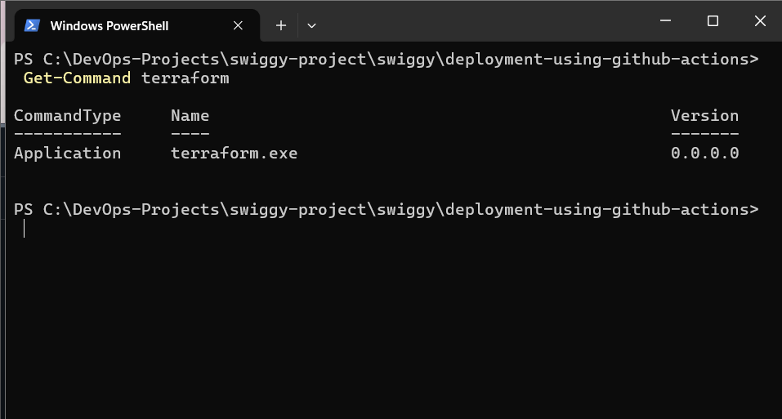

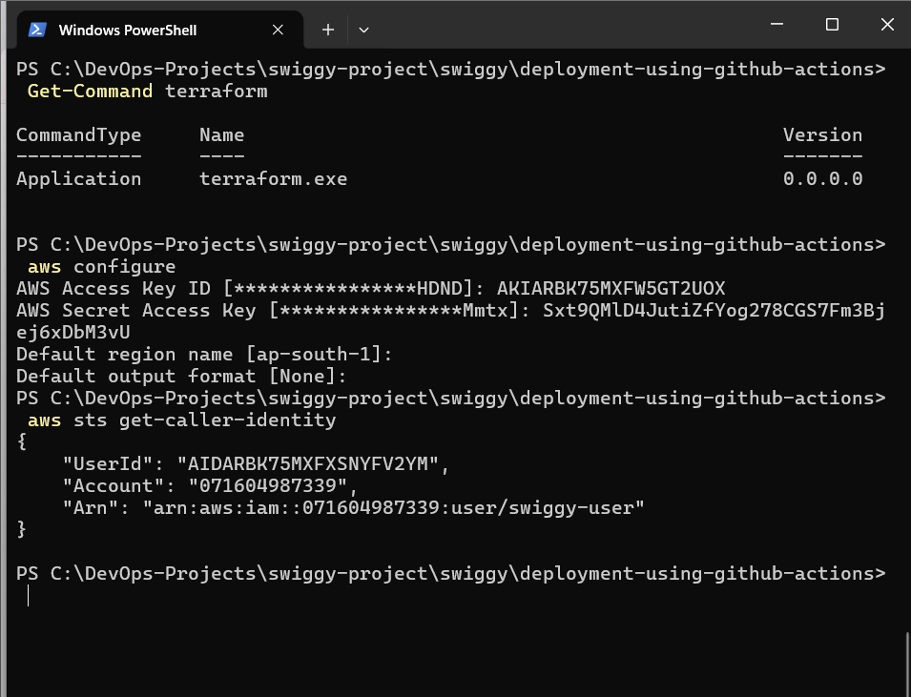

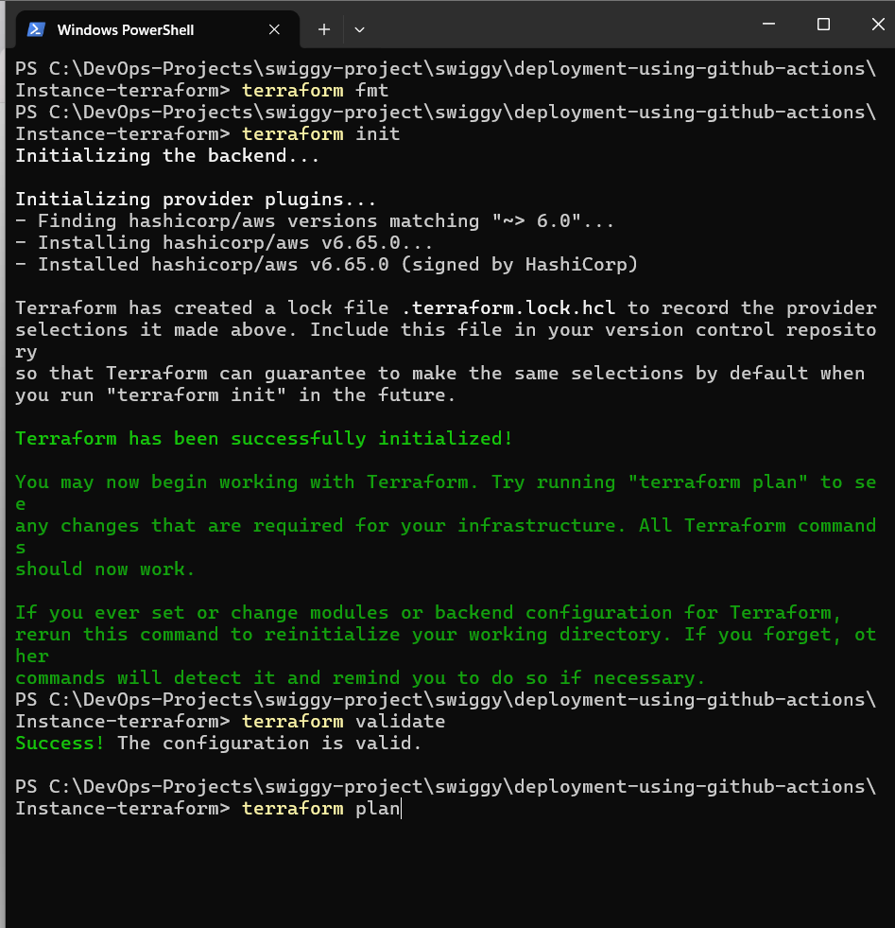

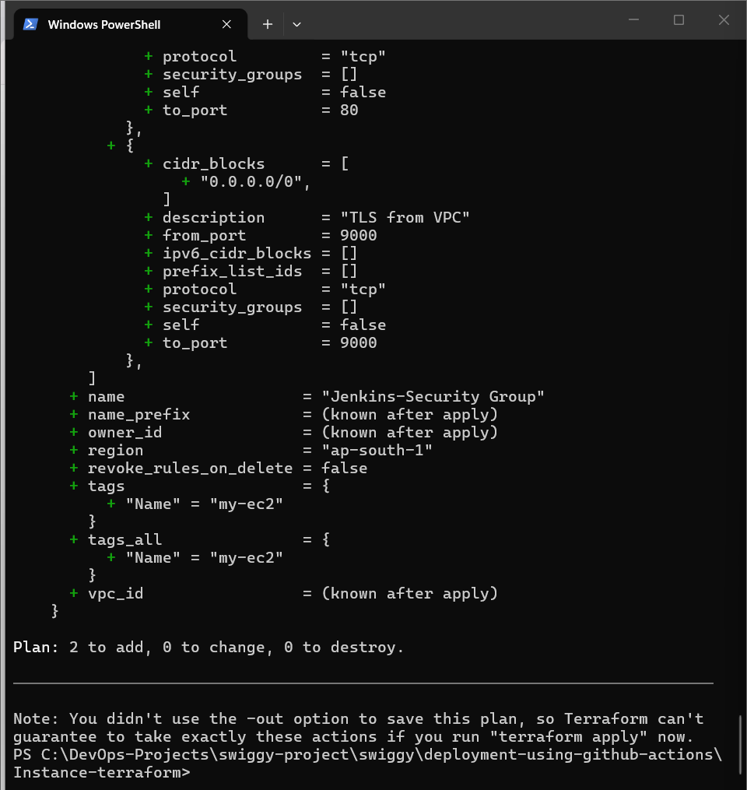

TF plan command

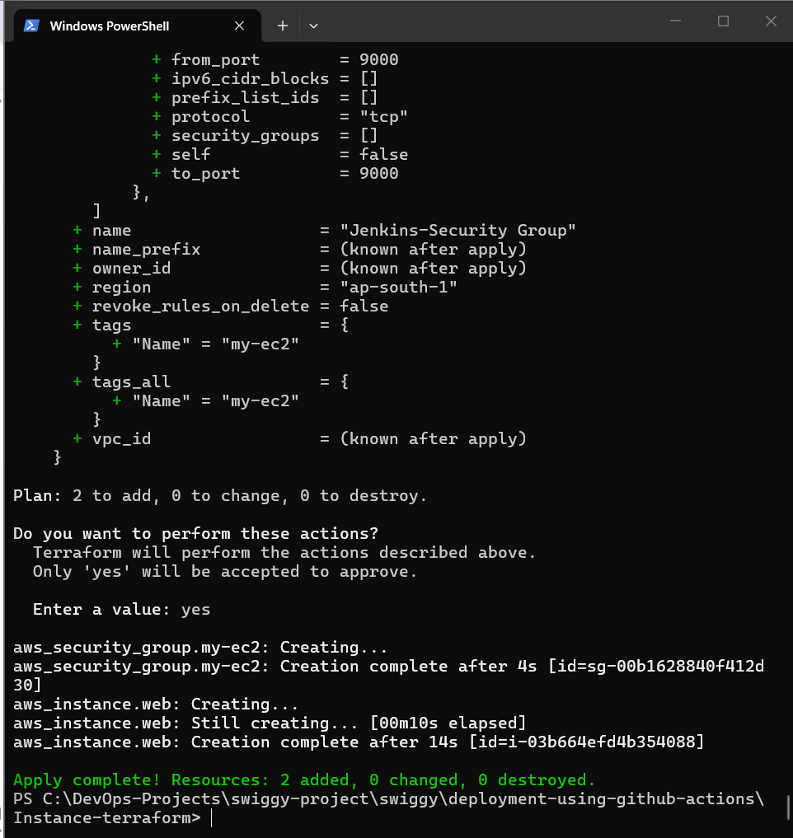

TF Apply

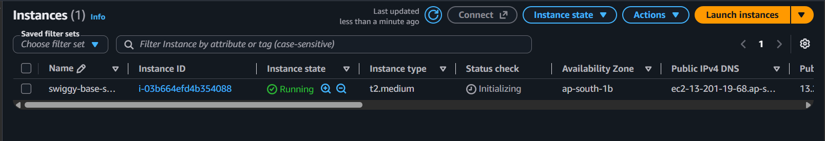

Ec2 created

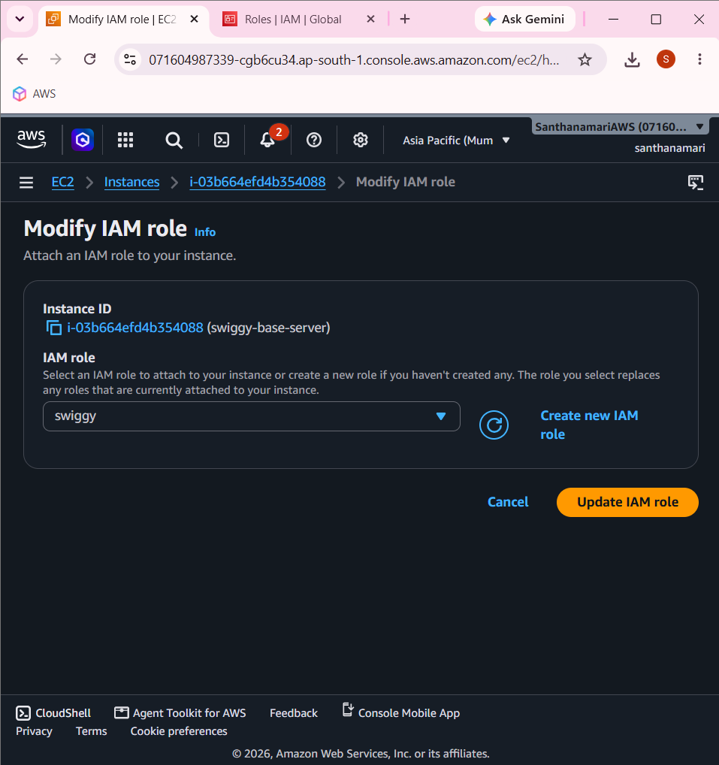

—----------------------------------------------------------------------------------------------------------------------------

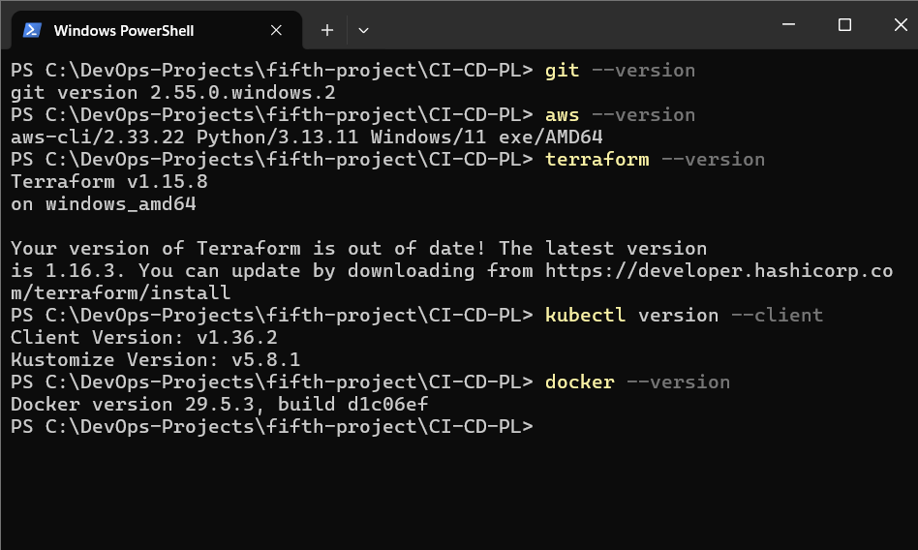

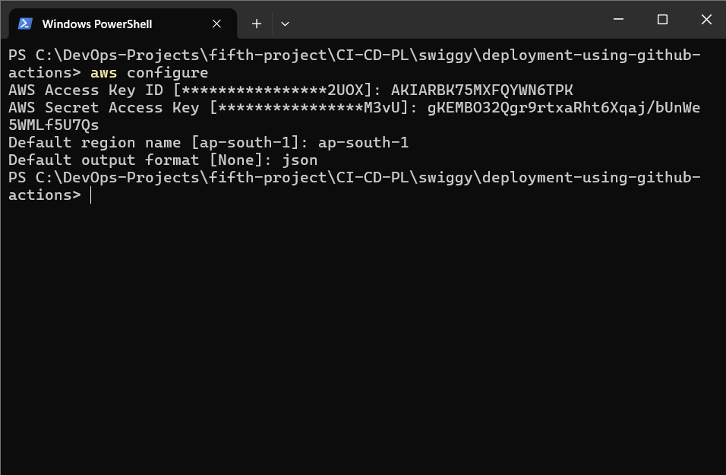

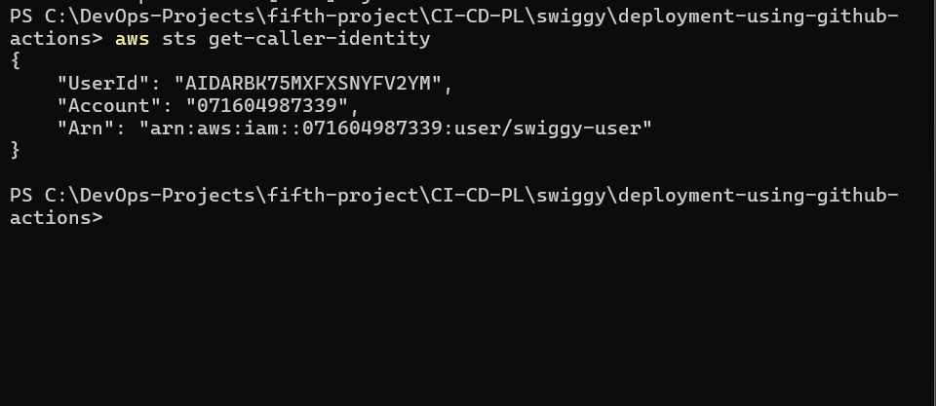

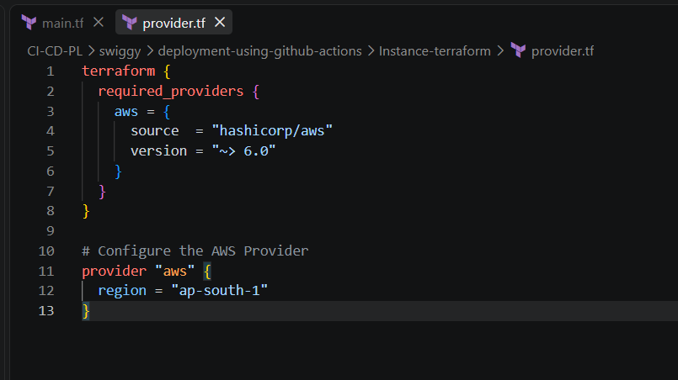

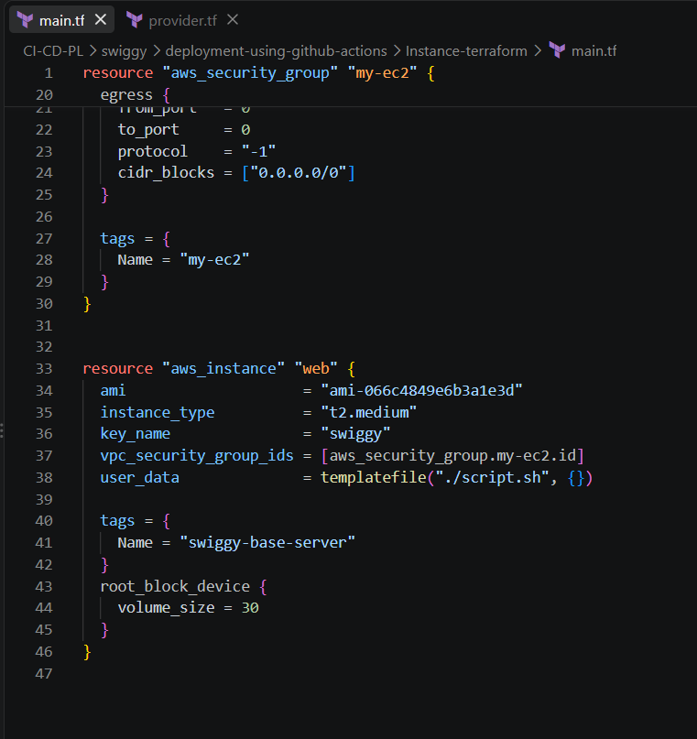

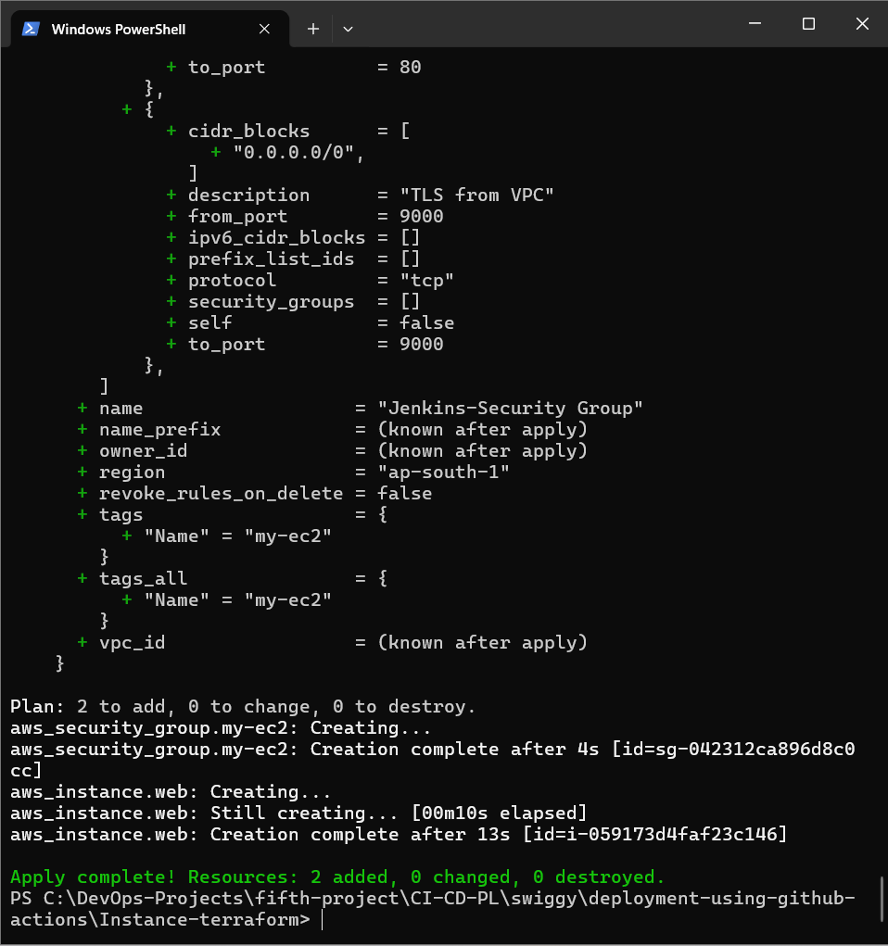

Install docker on ec2 terminal => sudo dnf install docker -y

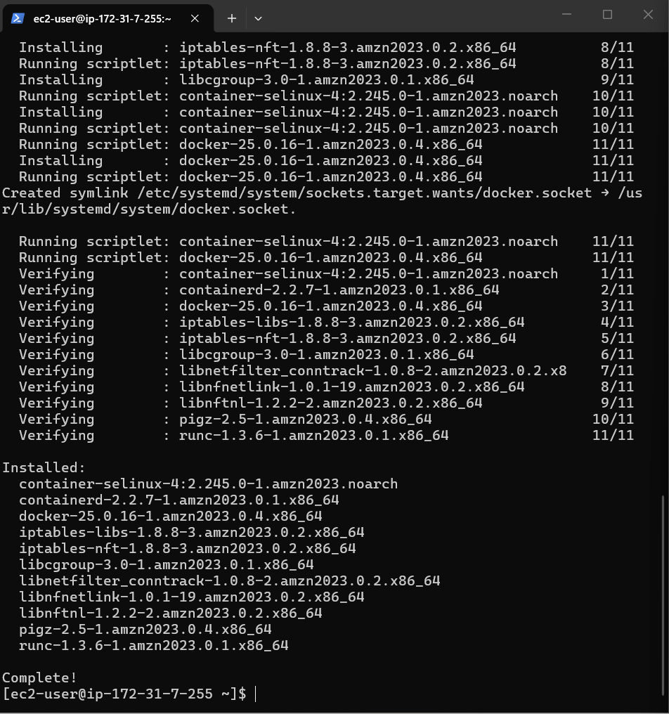

sudo systemctl start docker
sudo systemctl enable docker

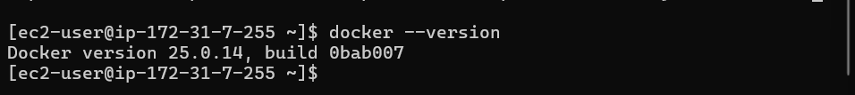

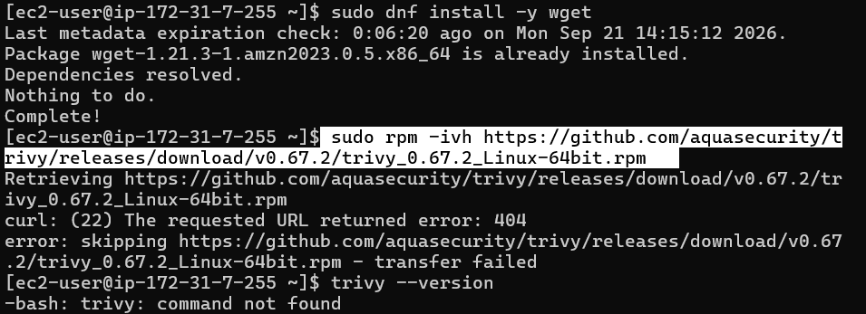

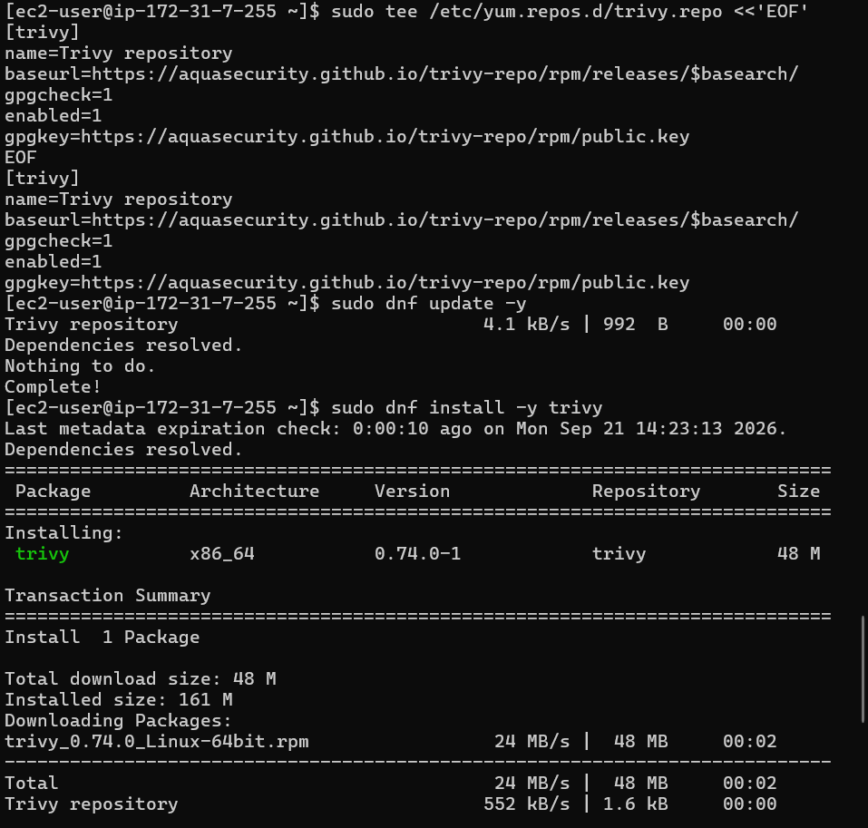

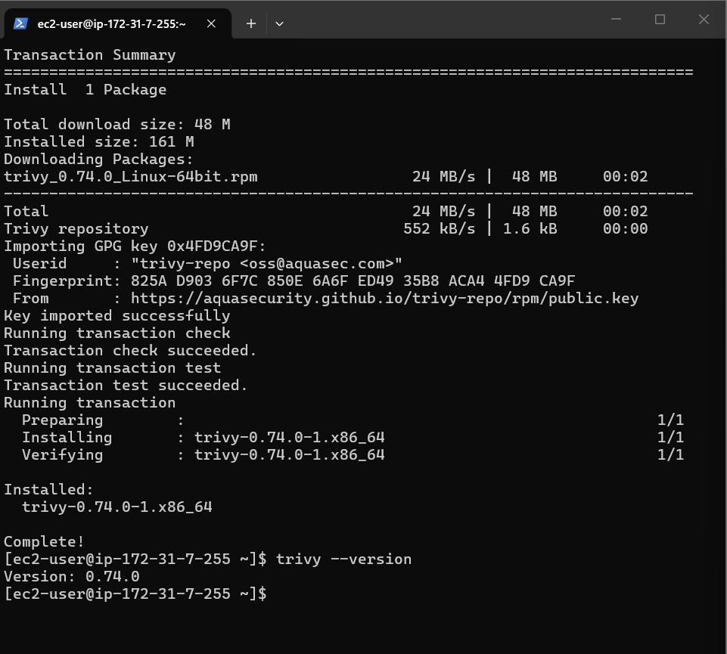

We use trivy for scan image before deploy app to aws eks

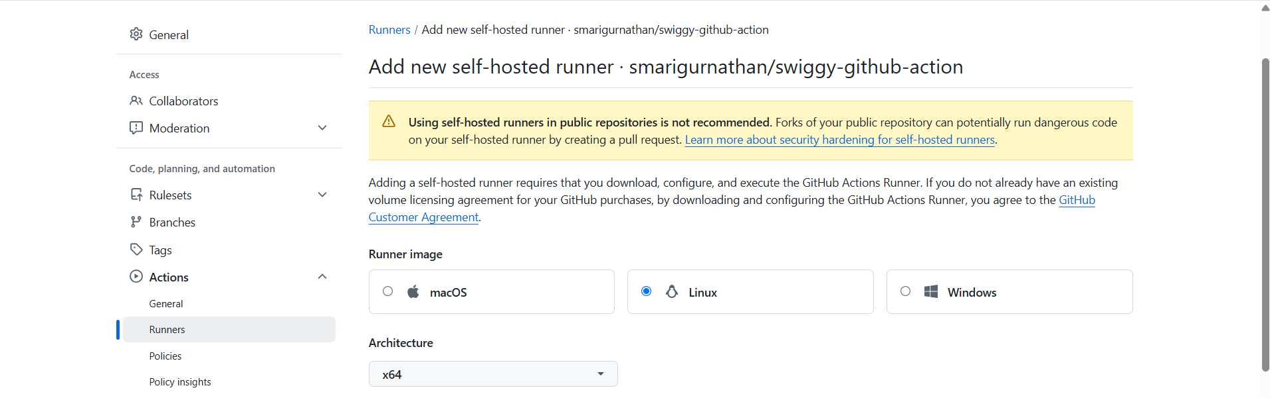

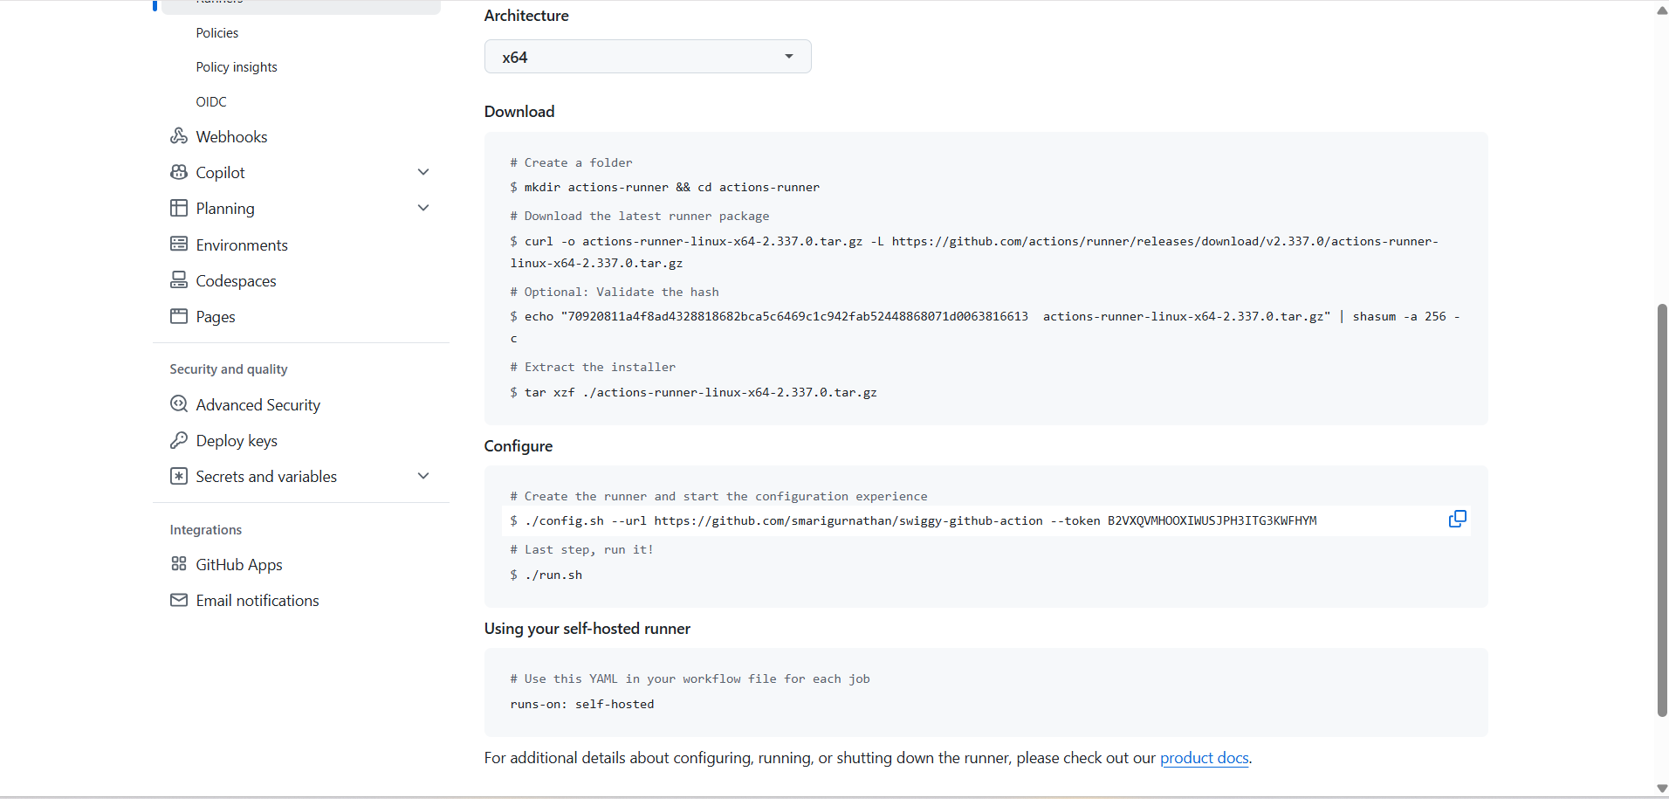

# Create a folder
$ mkdir actions-runner && cd actions-runner
# Download the latest runner package
$ curl -o actions-runner-linux-x64-2.337.0.tar.gz -L https://github.com/actions/runner/releases/download/v2.337.0/actions-runner-linux-x64-2.337.0.tar.gz
# Optional: Validate the hash
$ echo "70920811a4f8ad4328818682bca5c6469c1c942fab52448868071d0063816613 actions-runner-linux-x64-2.337.0.tar.gz" | shasum -a 256 -c
# Extract the installer
$ tar xzf ./actions-runner-linux-x64-2.337.0.tar.gz

Configure
# Create the runner and start the configuration experience
$ ./config.sh --url https://github.com/smarigurnathan/swiggy-github-action --token B2VXQVMHOOXIWUSJPH3ITG3KWFHYM
# Last step, run it!
$ ./run.sh

Using your self-hosted runner
# Use this YAML in your workflow file for each job
runs-on: self-hosted

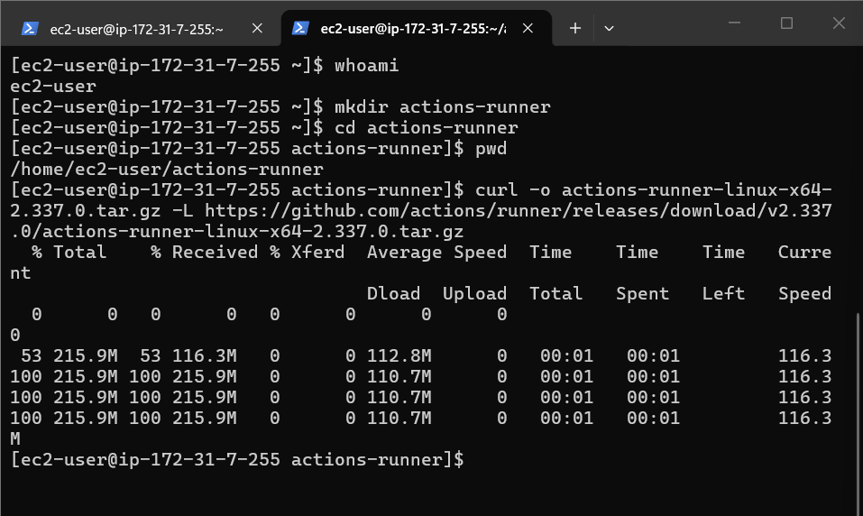
curl -o actions-runner-linux-x64-2.337.0.tar.gz -L https://github.com/actions/runner/releases/download/v2.337.0/actions-runner-linux-x64-2.337.0.tar.gz

the command downloads the GitHub Actions self-hosted runner software onto your EC2 instance.

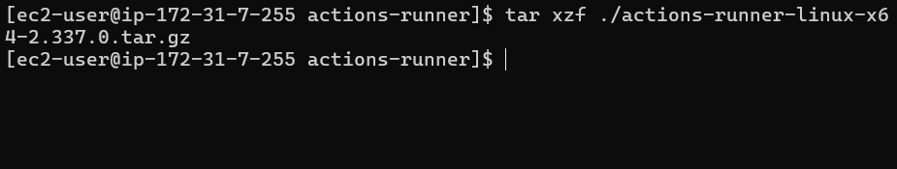

tar xzf ./actions-runner-linux-x64-2.337.0.tar.gz

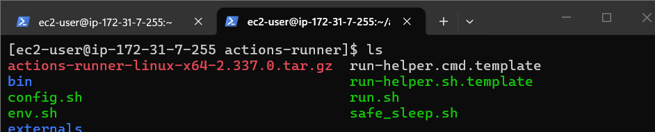

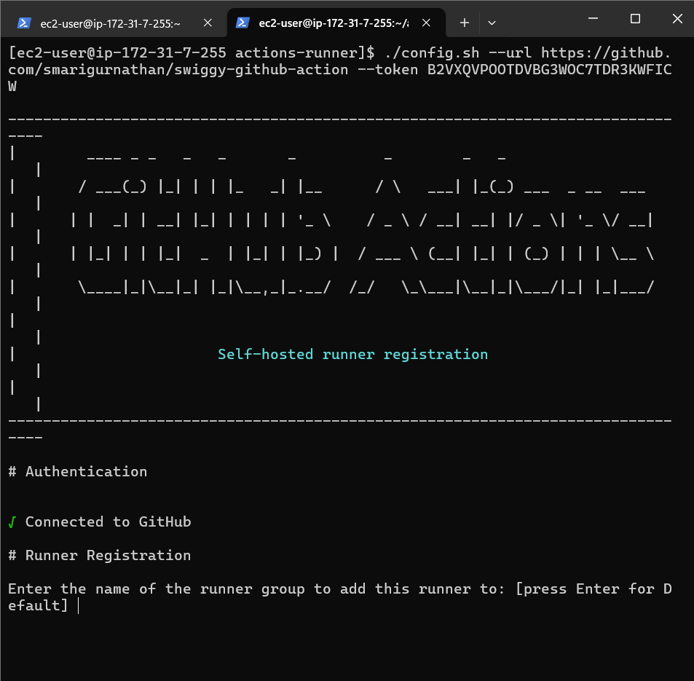

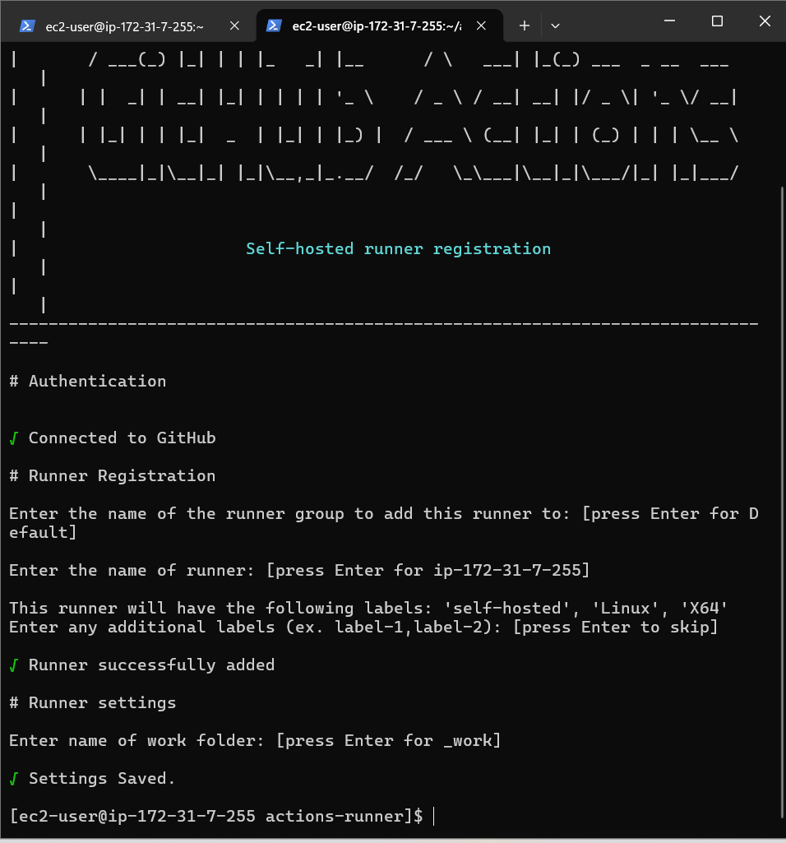

Runner configured

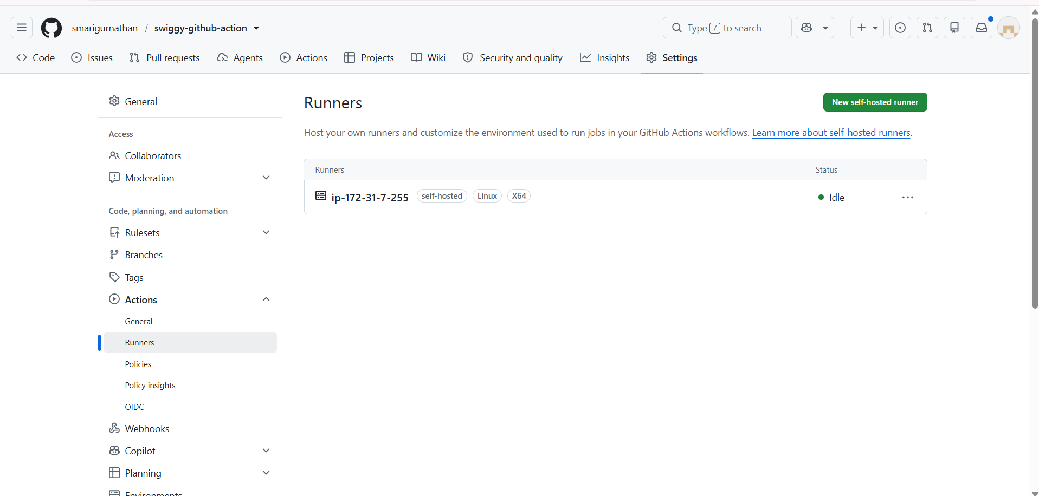

EC2 instance is registered as a GitHub Actions runner and is ready to execute GitHub Actions jobs.

Idle means the runner is connected to GitHub but is currently not executing a job.
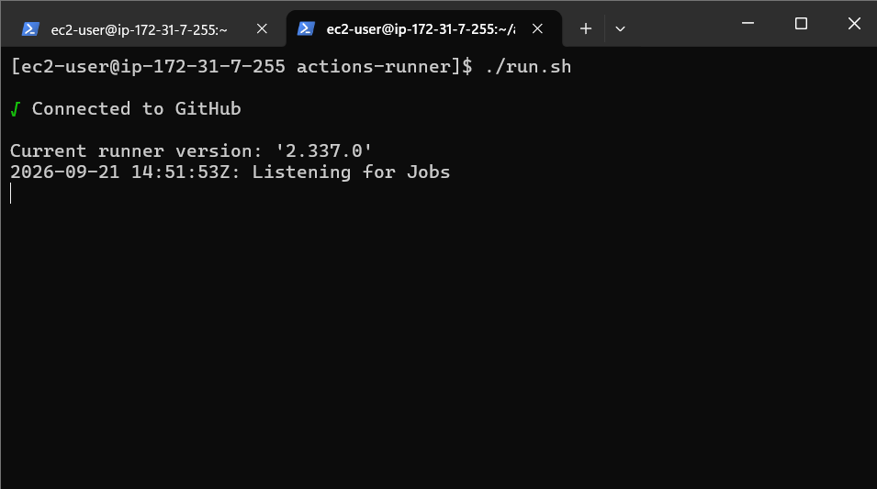

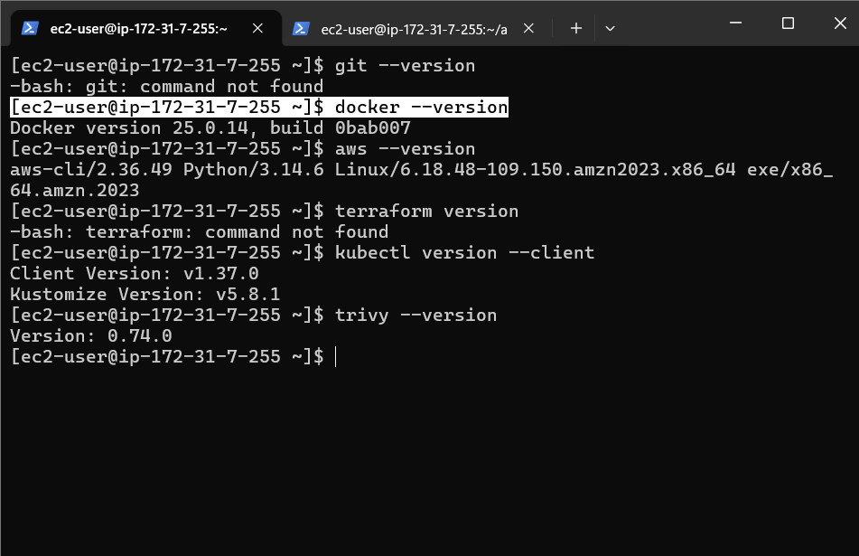

docker run -d \
--name sonarqube \
-p 9000:9000 \
sonarqube:lts-community
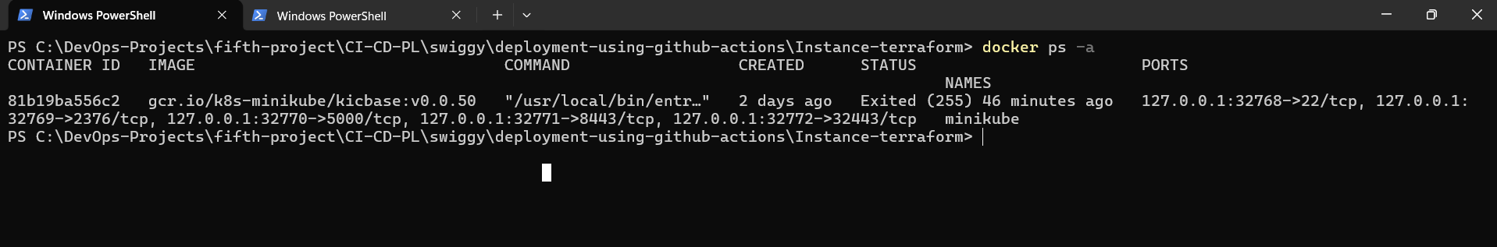

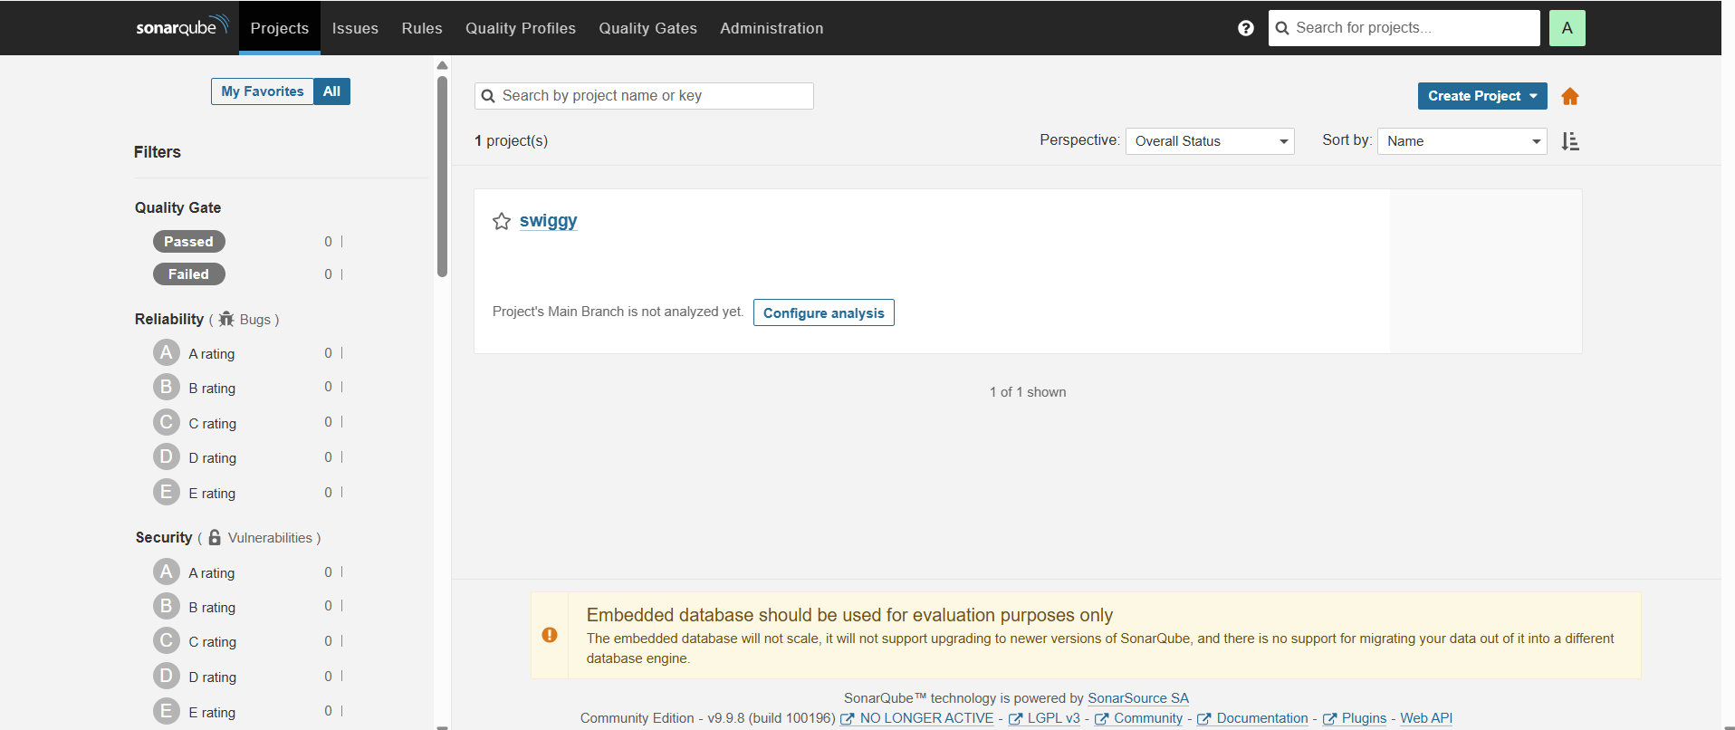

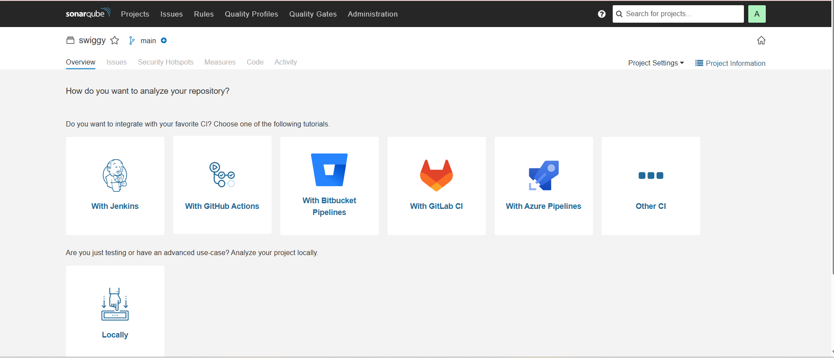

GHA

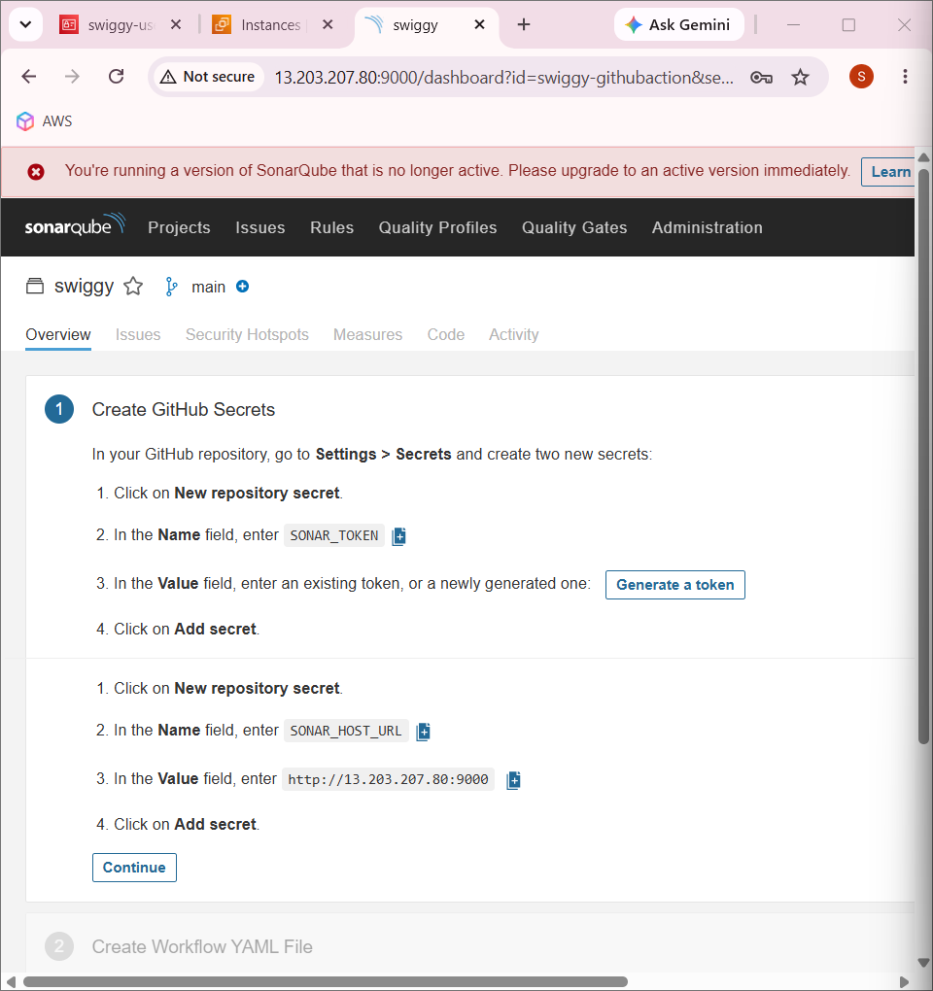

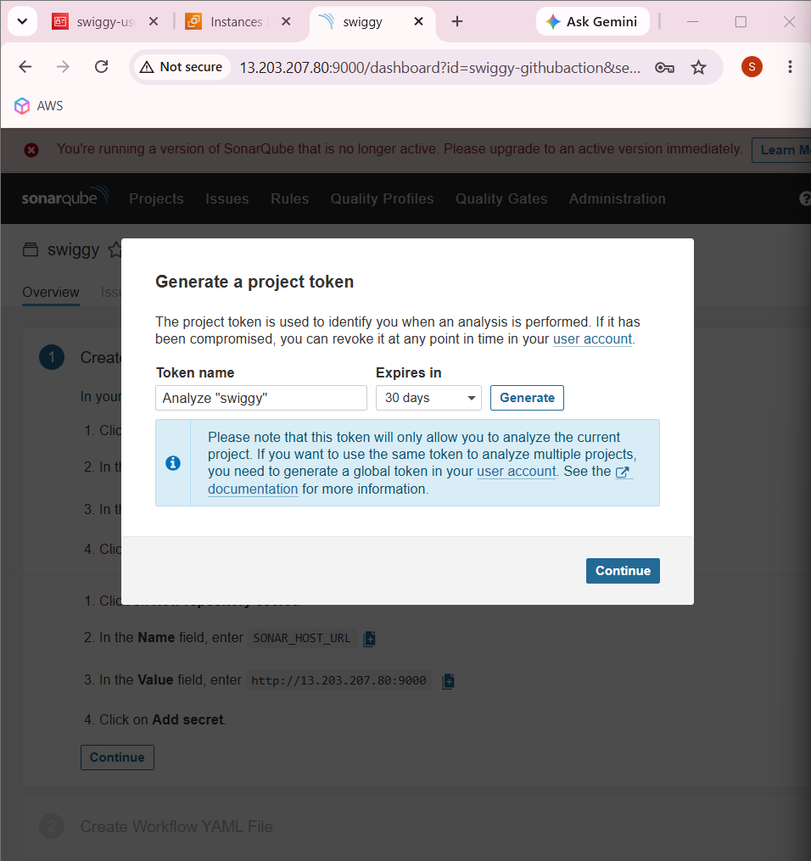

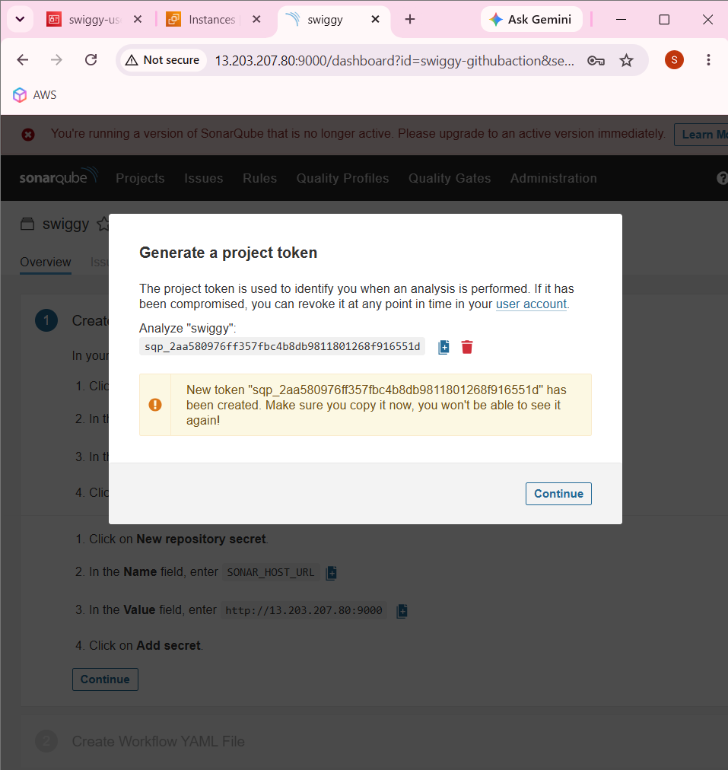

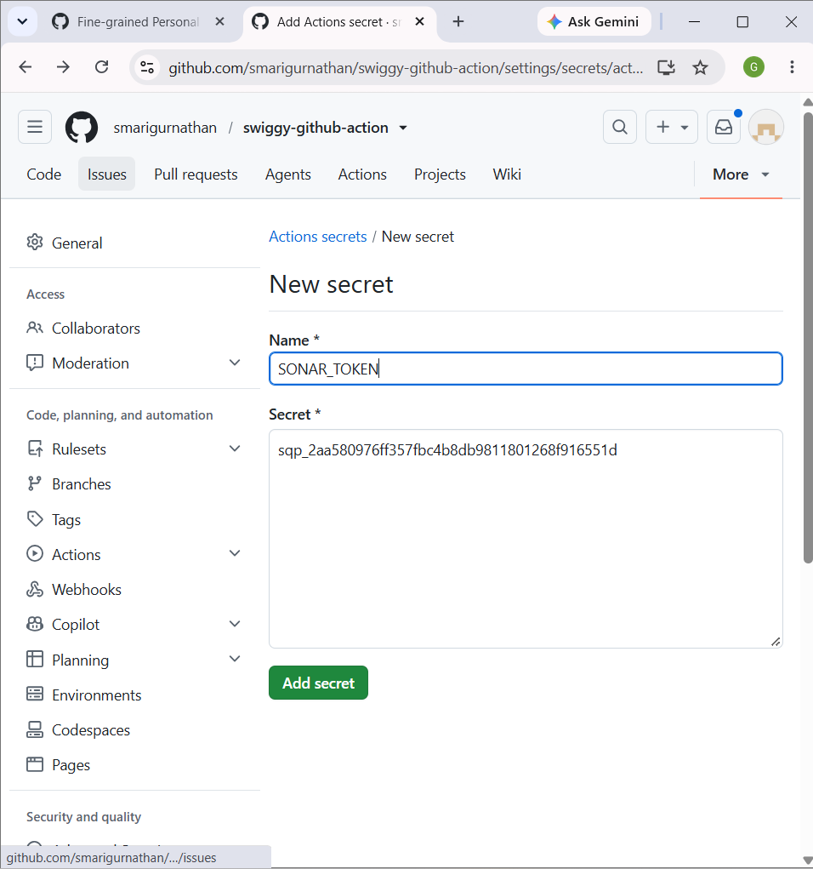

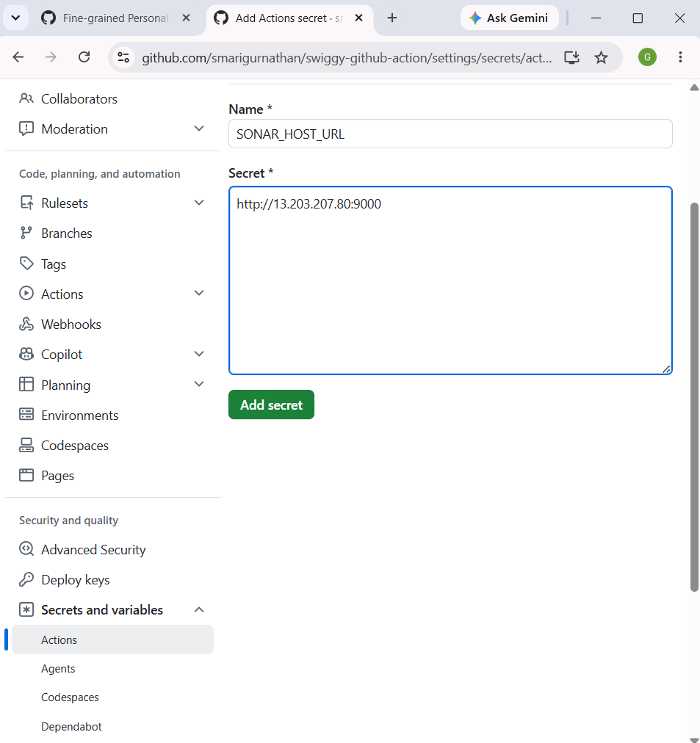

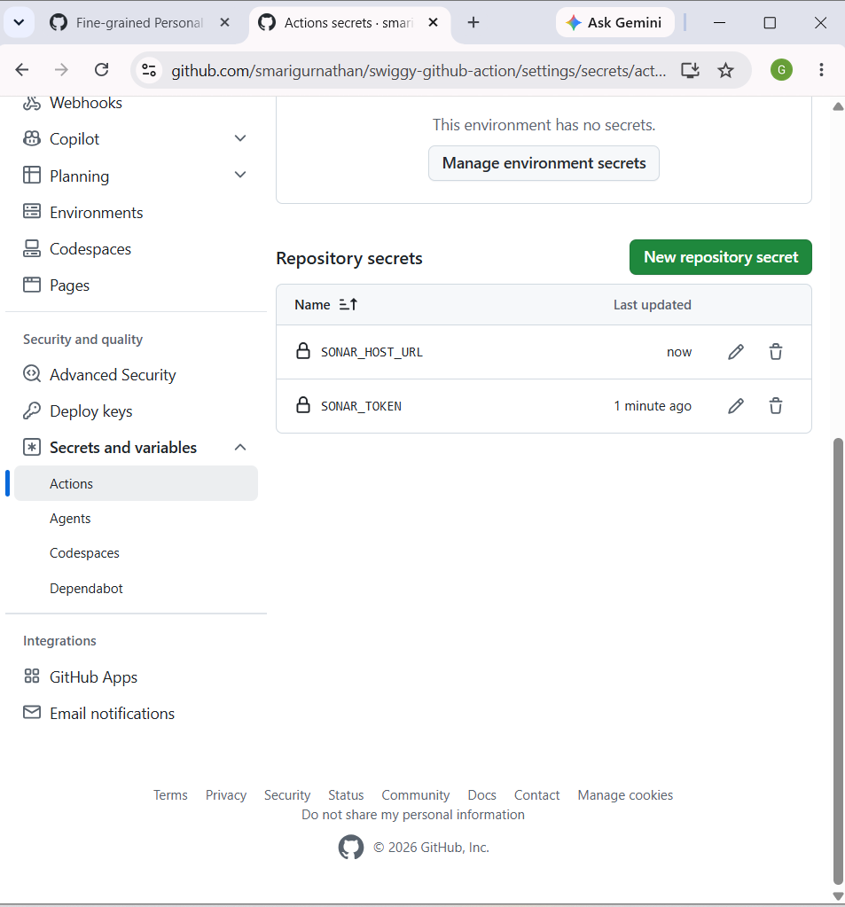

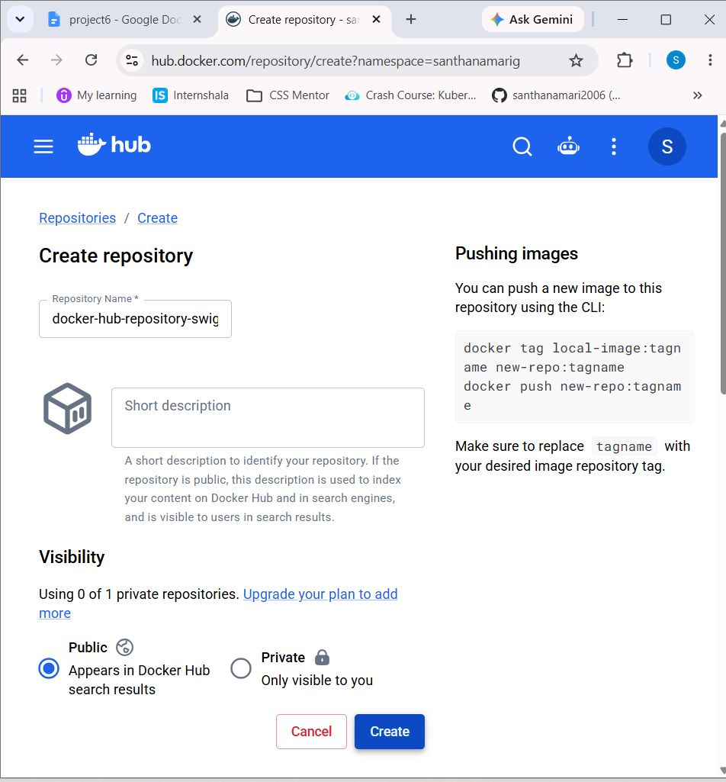

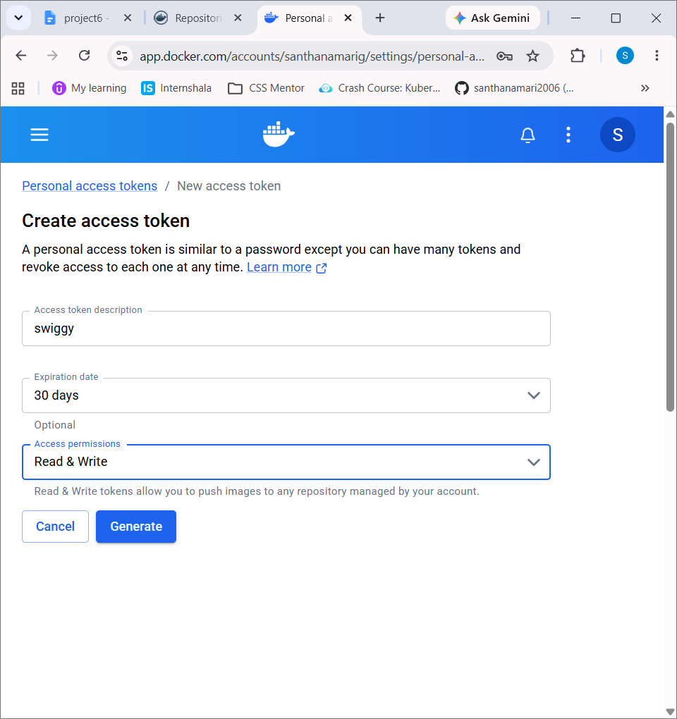

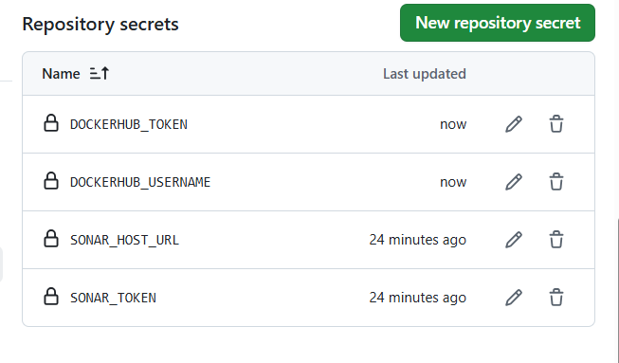



Run on local machine

docker build -t swiggy-clone .

docker images
docker run -d --name swiggy-test -p 3001:3000 swiggy

docker ps

http://localhost:3001/

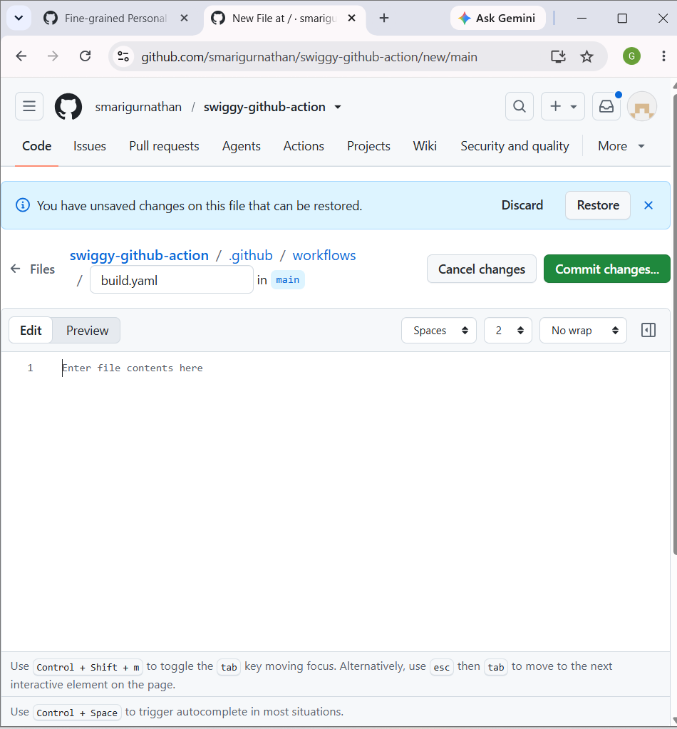

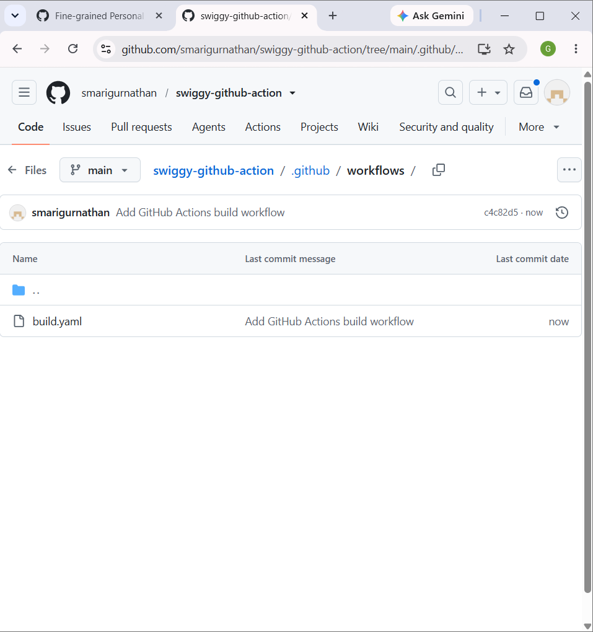

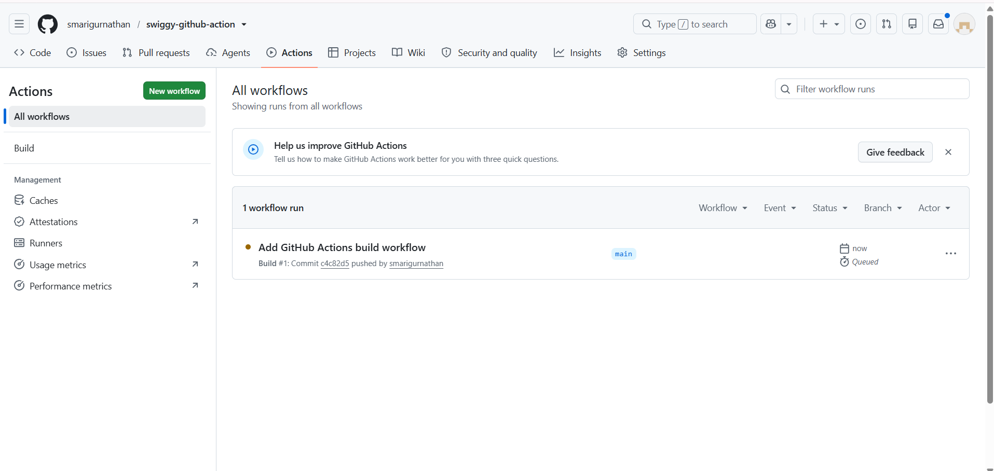

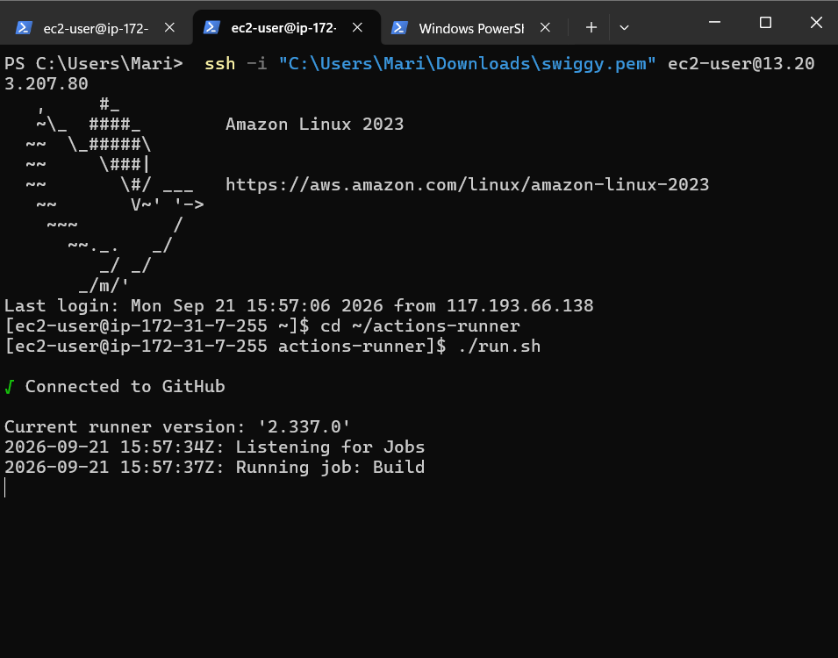

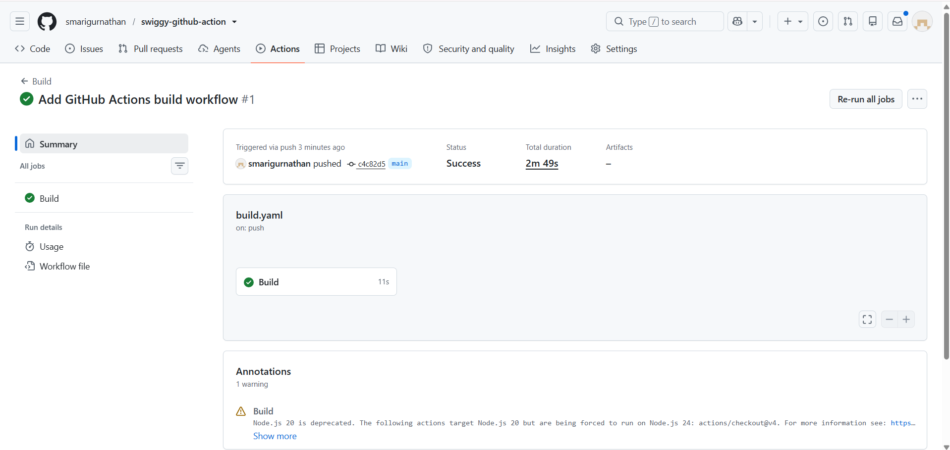

sudo dnf install -y git

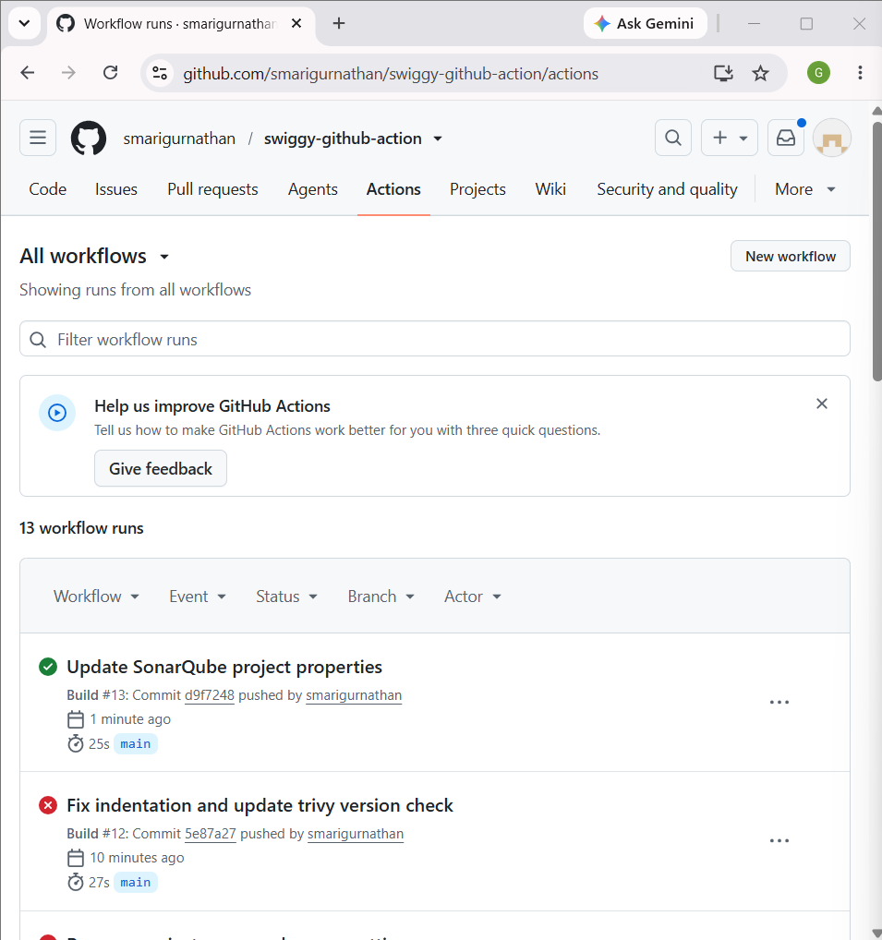

squ_a1cb29941ae775e56606bbb71b1e72b64fbb9201
Sonar

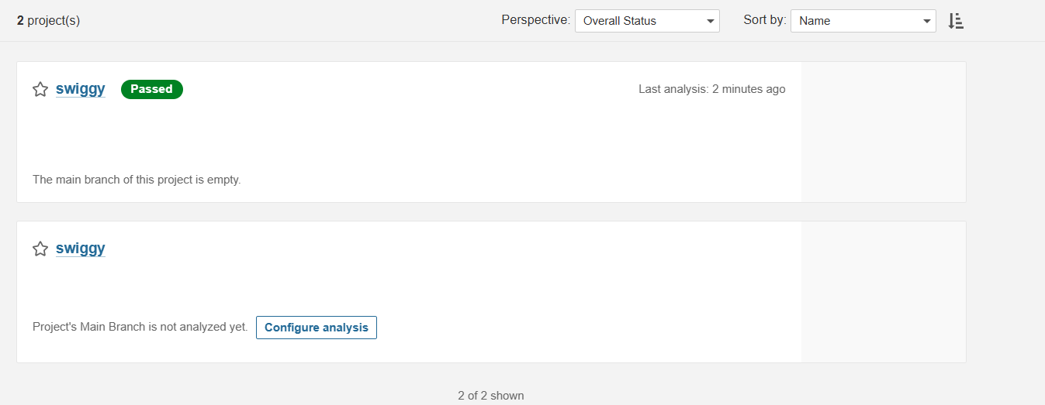

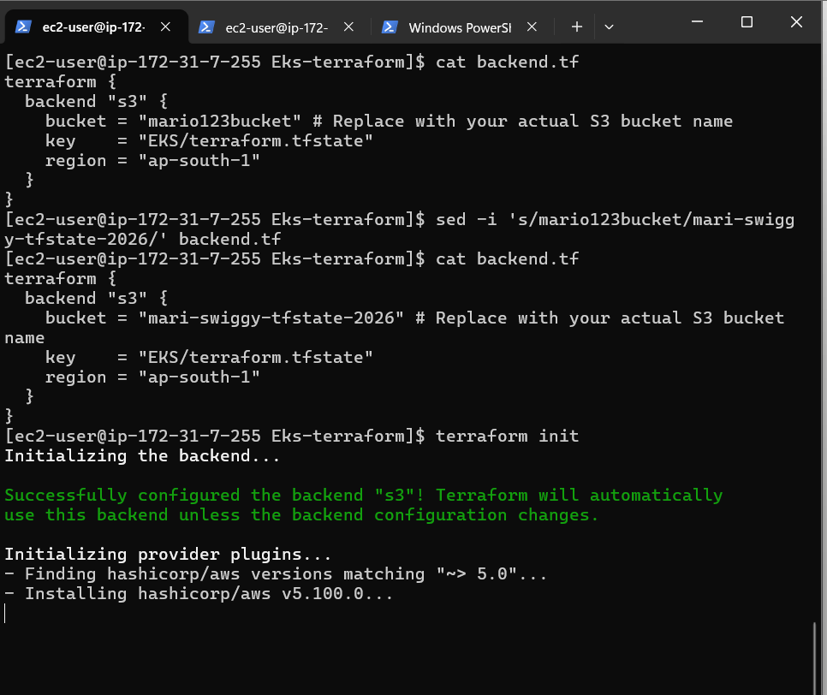

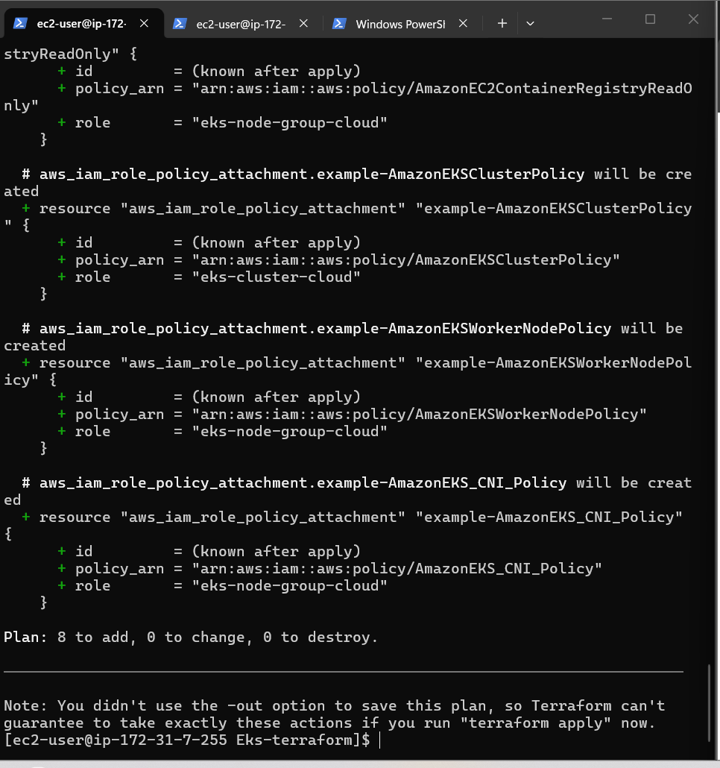

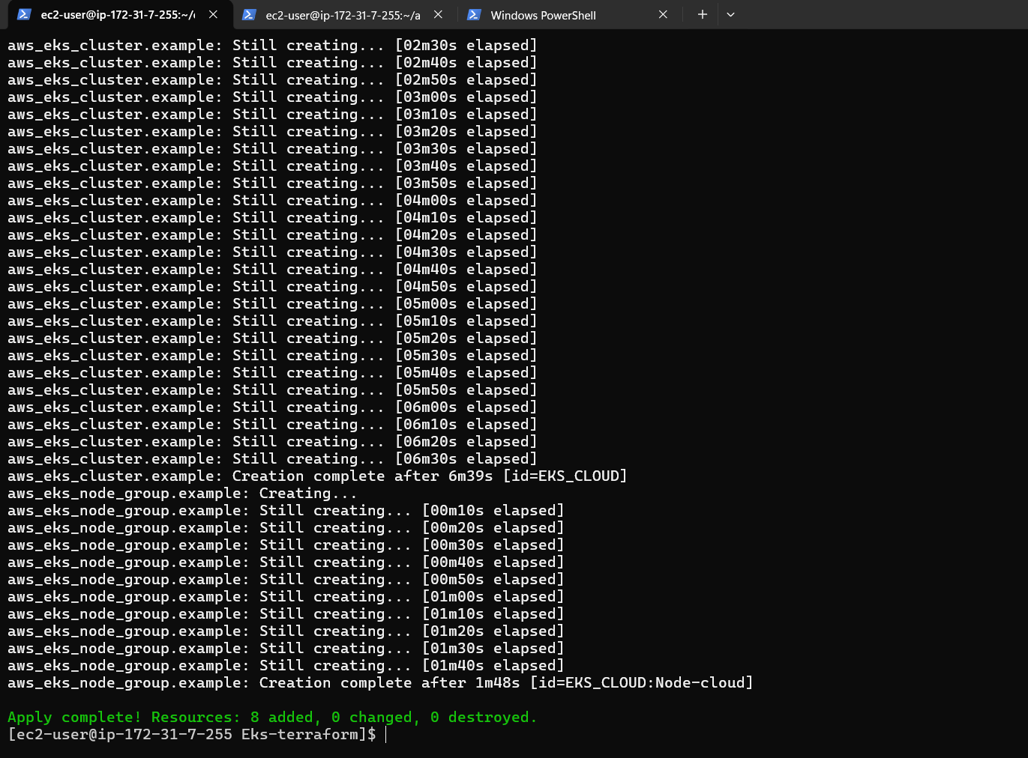

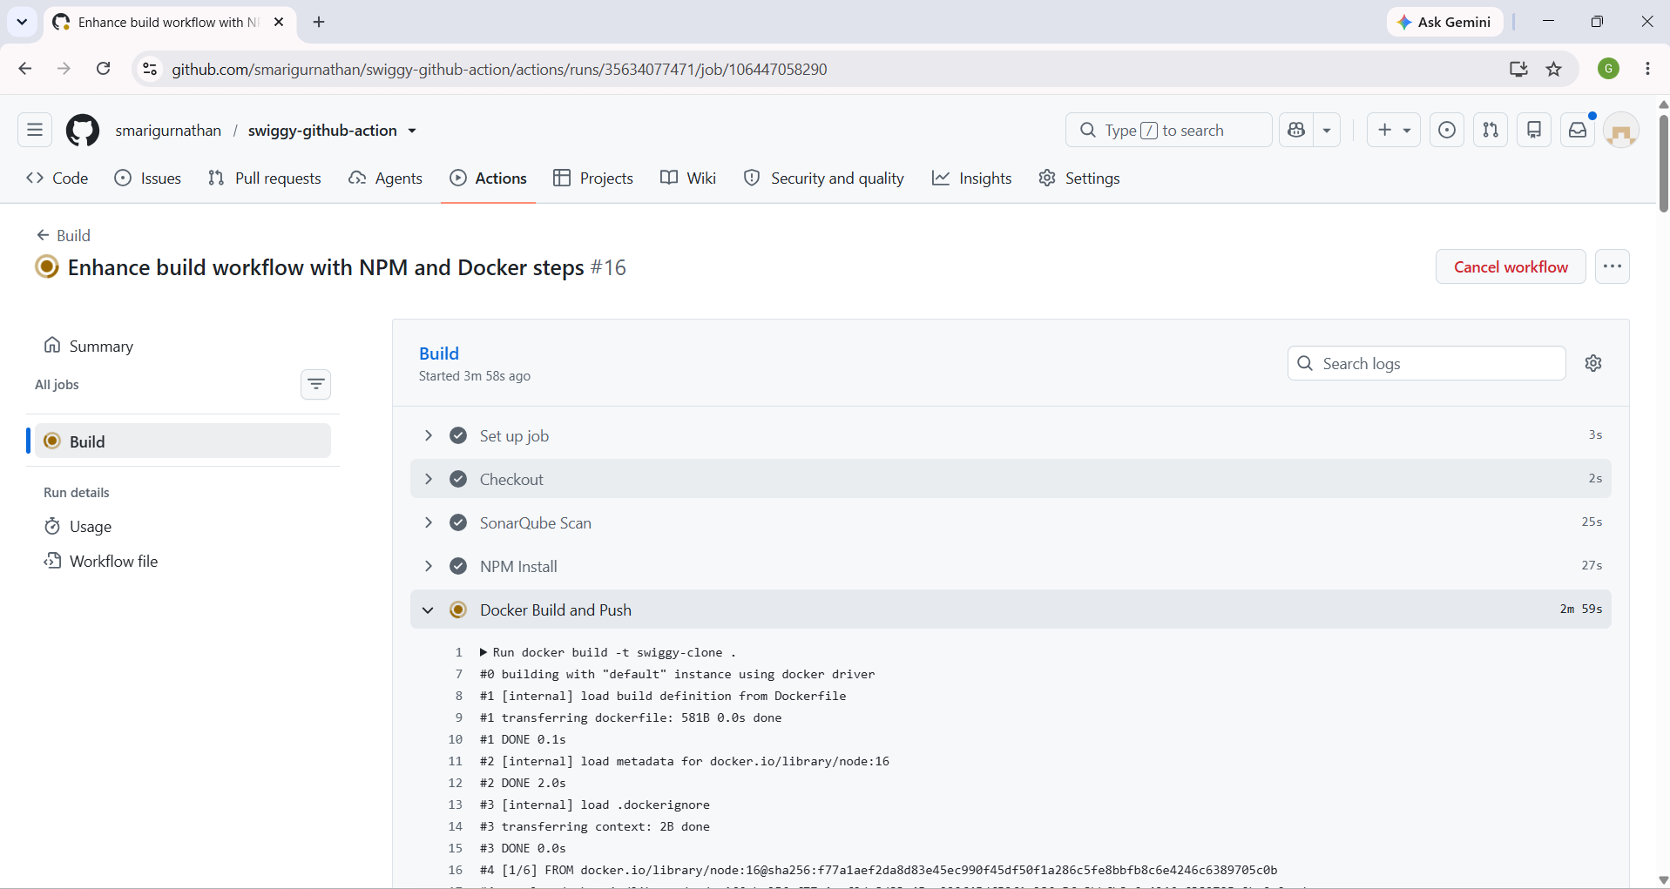

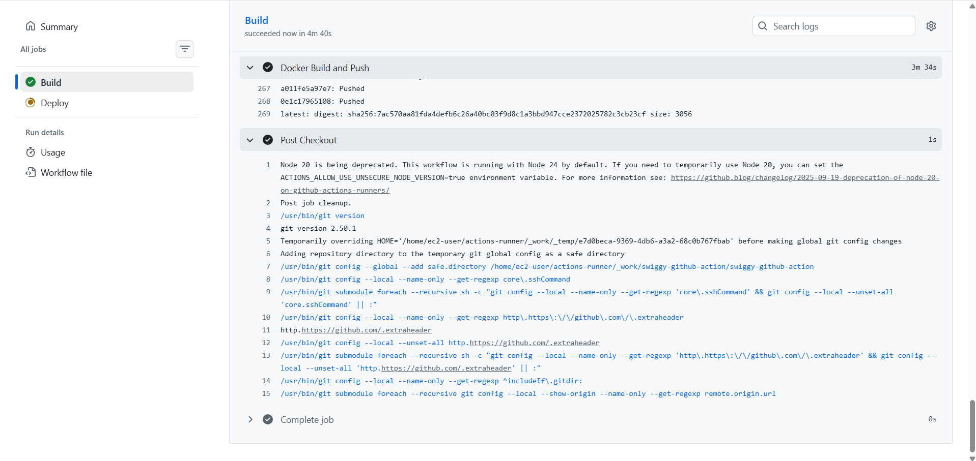

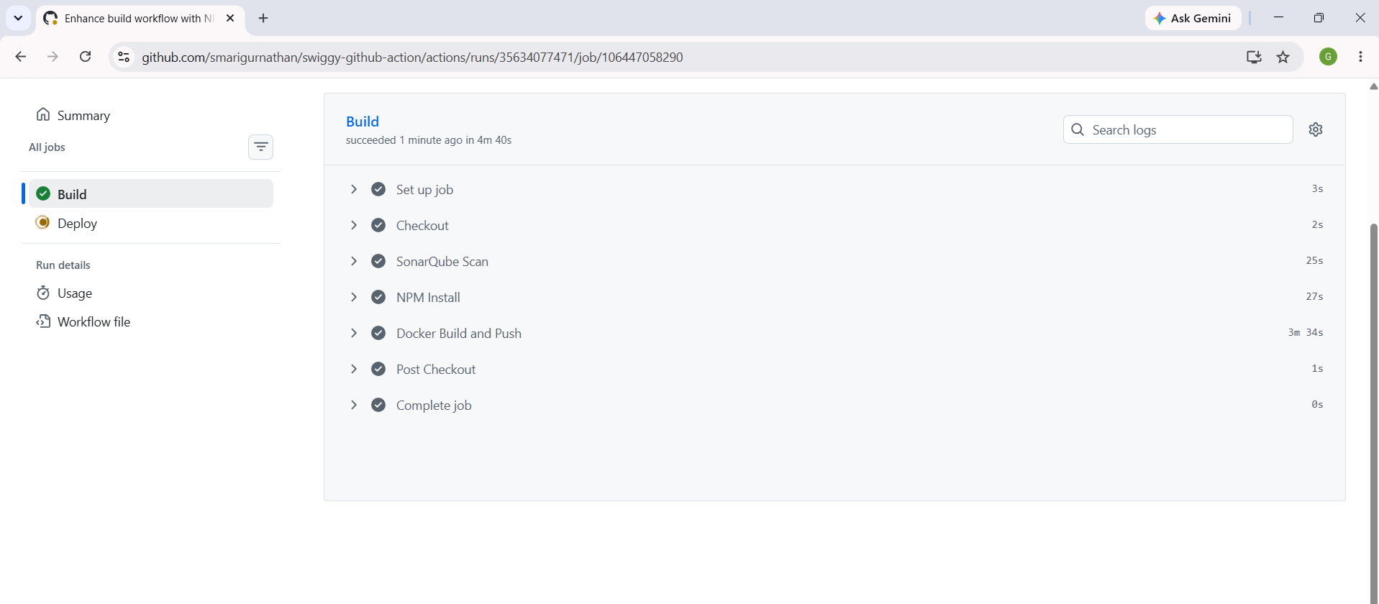
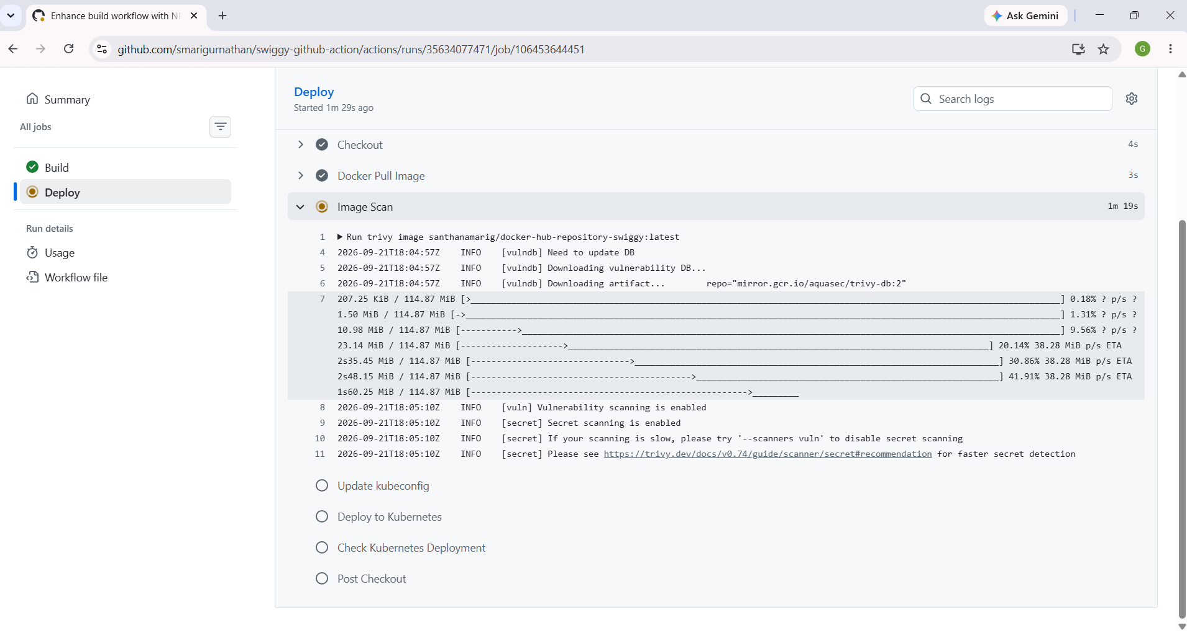

Deploy

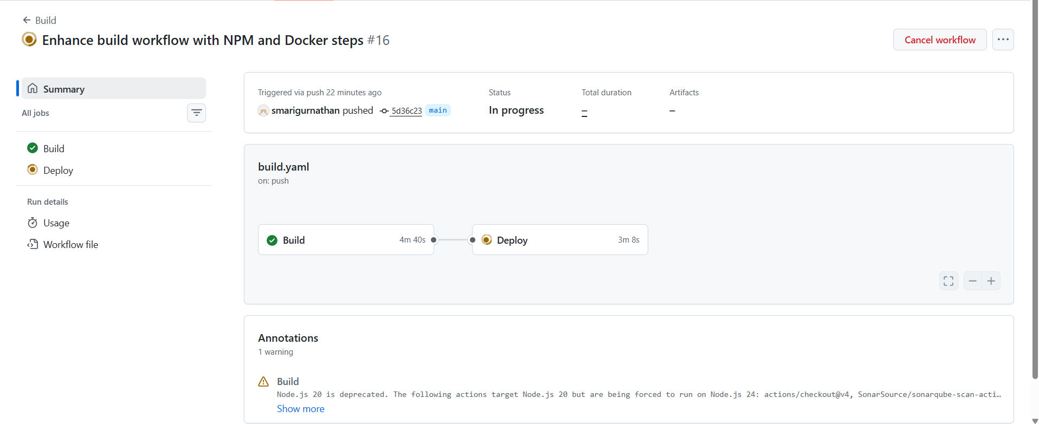

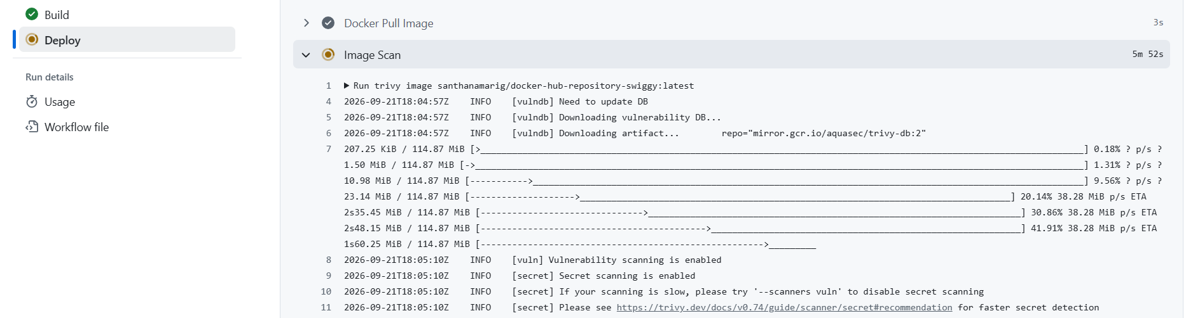

deployment pipeline is running Trivy image scanning against your Docker image

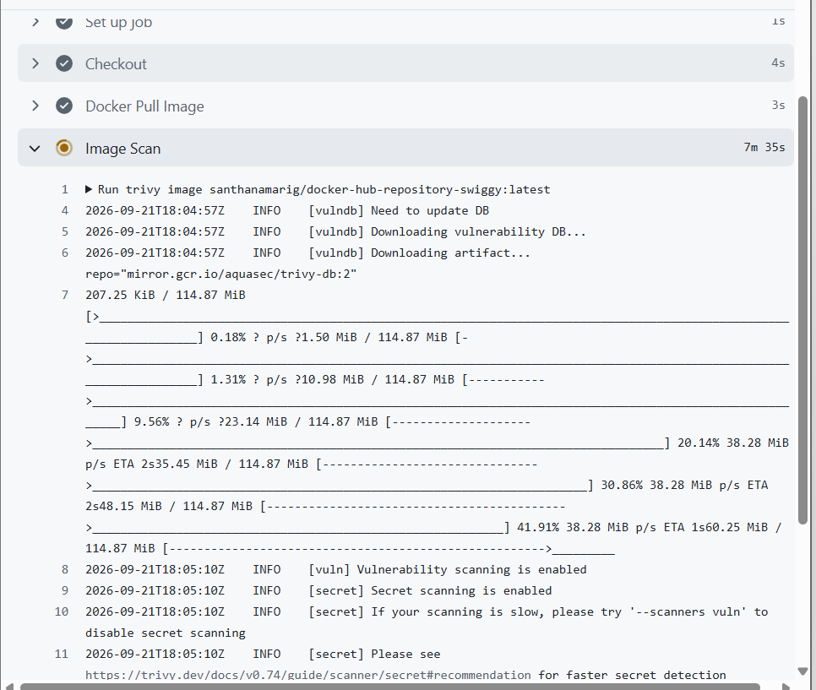

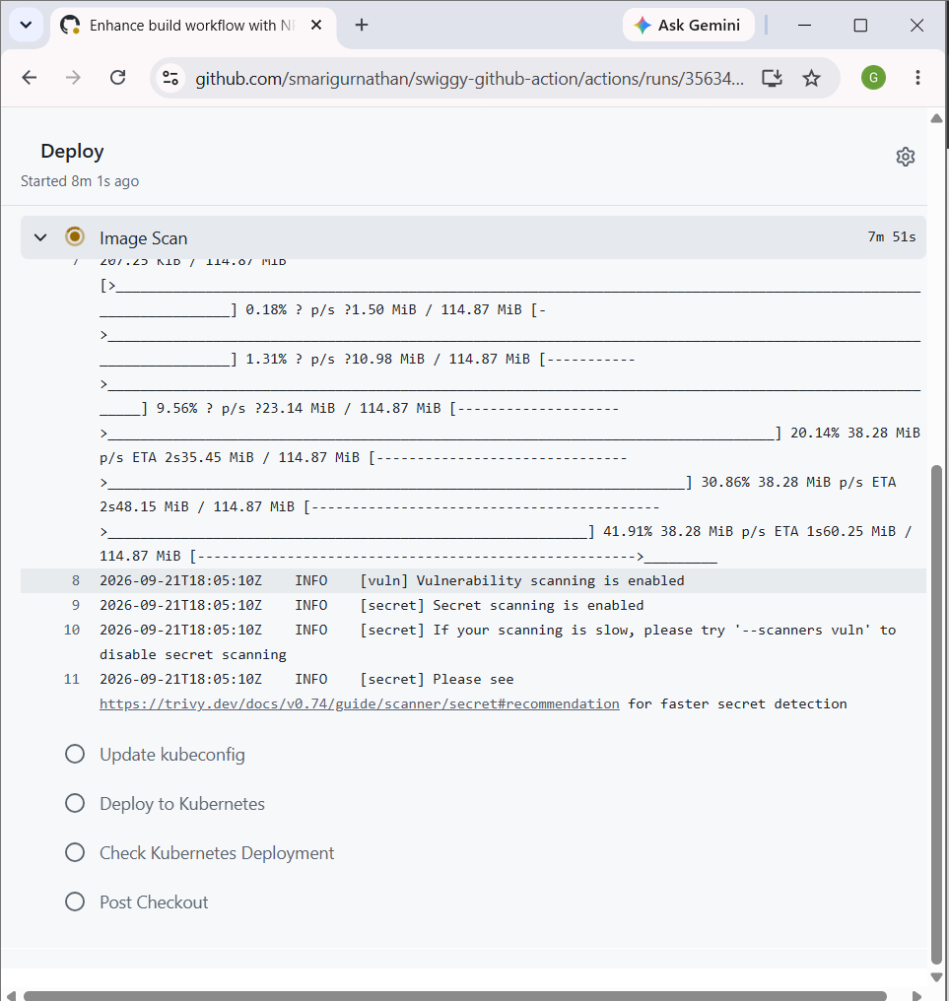

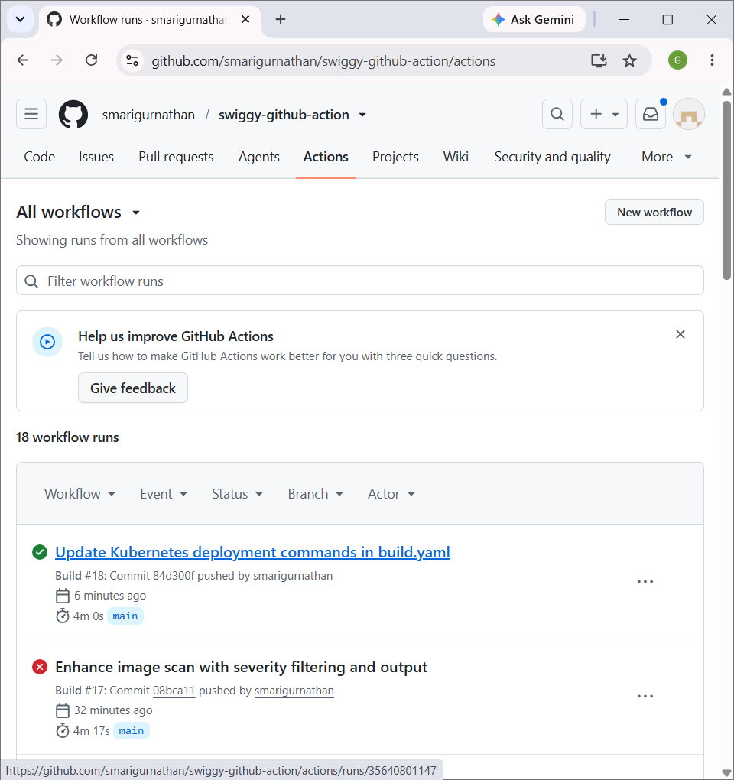

http://a7cab988eab234e57a4b1a759582da47-1153818248.ap-south-1.elb.amazonaws.com/







